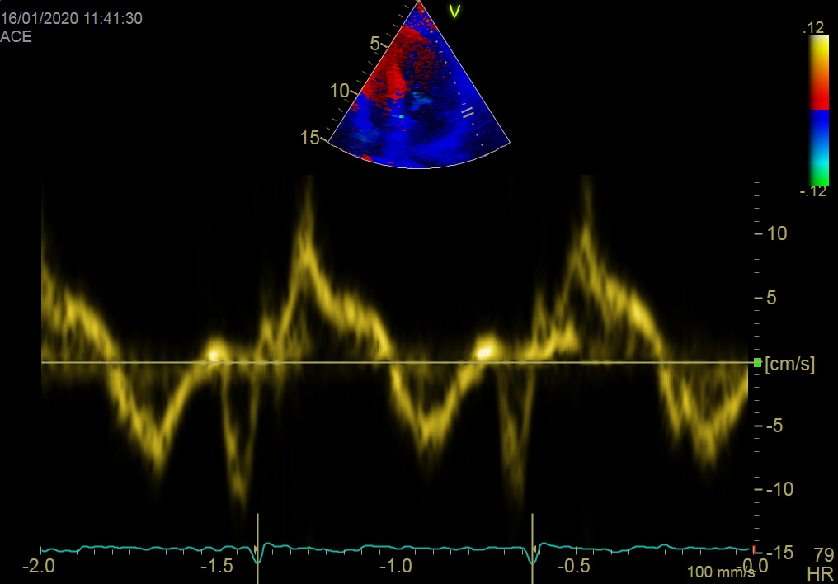
Figure 2. Tissue Doppler echocardiography. Reduction early diastolic velocity of the lateral mitral ring (8 cm / s) - component of the diastolic dysfunction.

