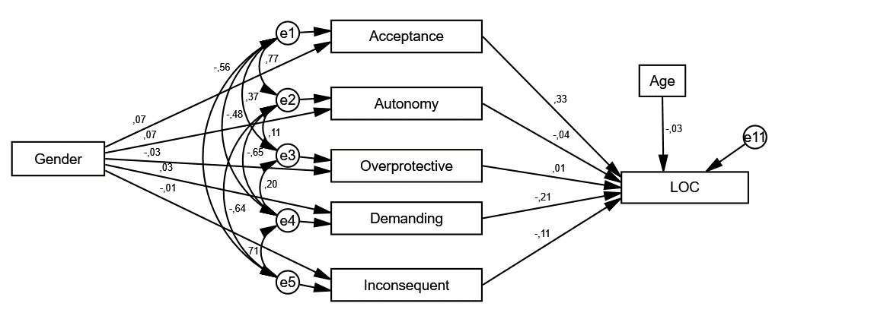
Fig. 1 Standardized regression coefficients for model 1 for mothers' attitude

