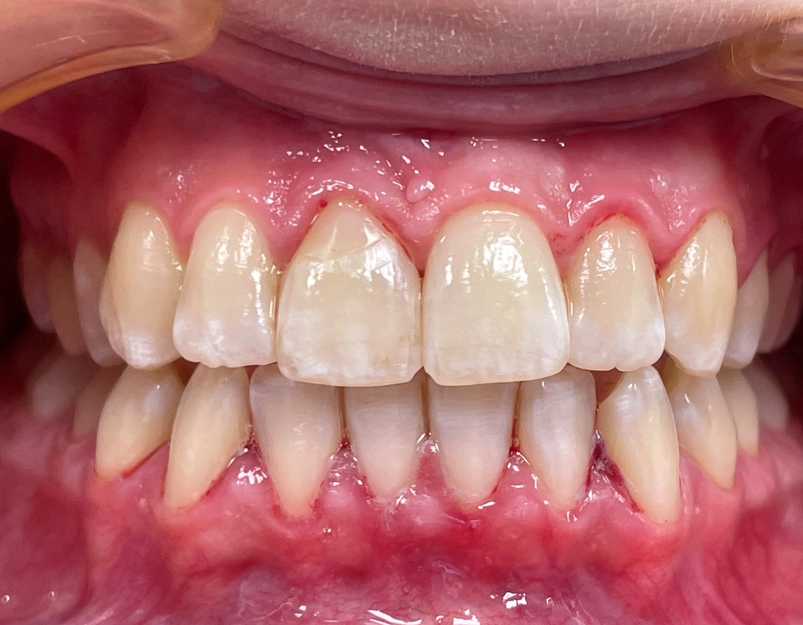

Figure 9. Intraoral photography showing good esthetic effect after 4 years of observation

