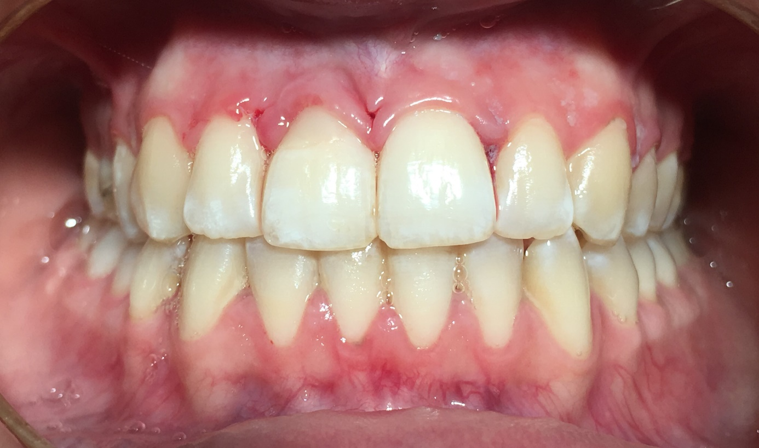

Figure 7. Intraoral photograph after seven days

