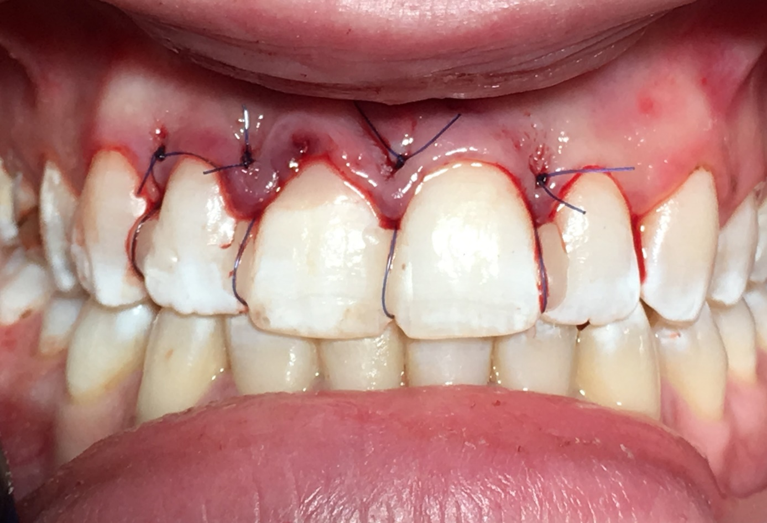

Figure 6. Intraoral photograph after flap reposition and suture

