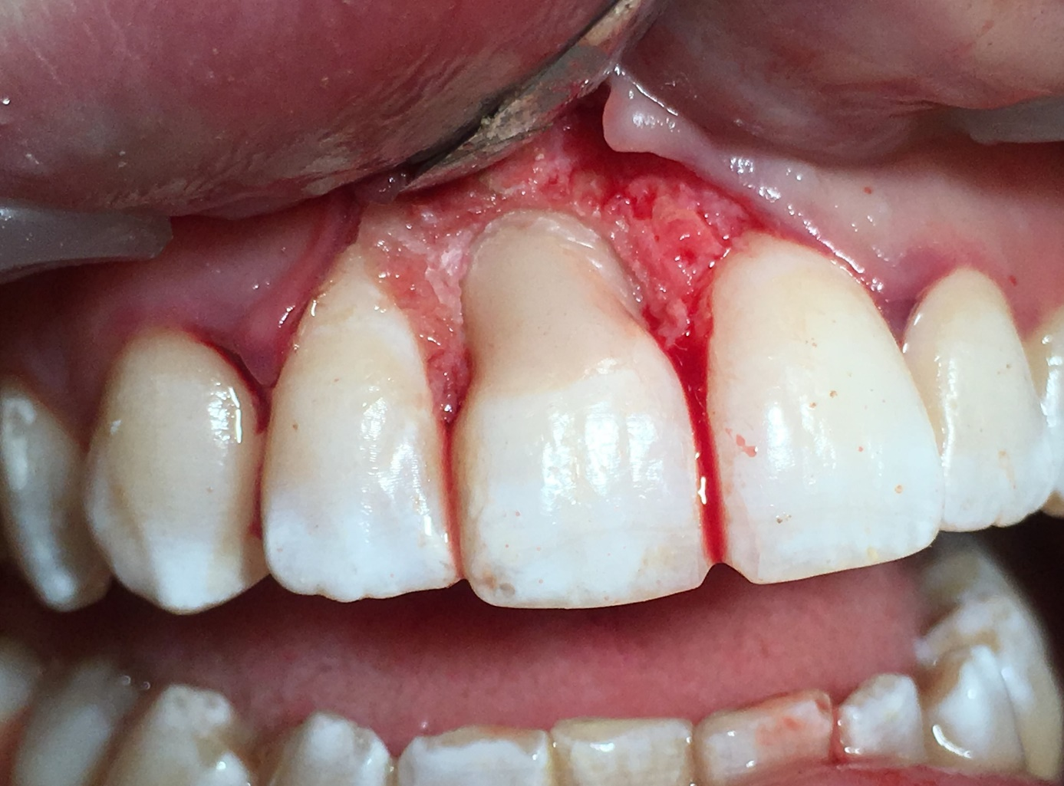

Figure 5. Resorption cavity restored with adhesive and resin composite

