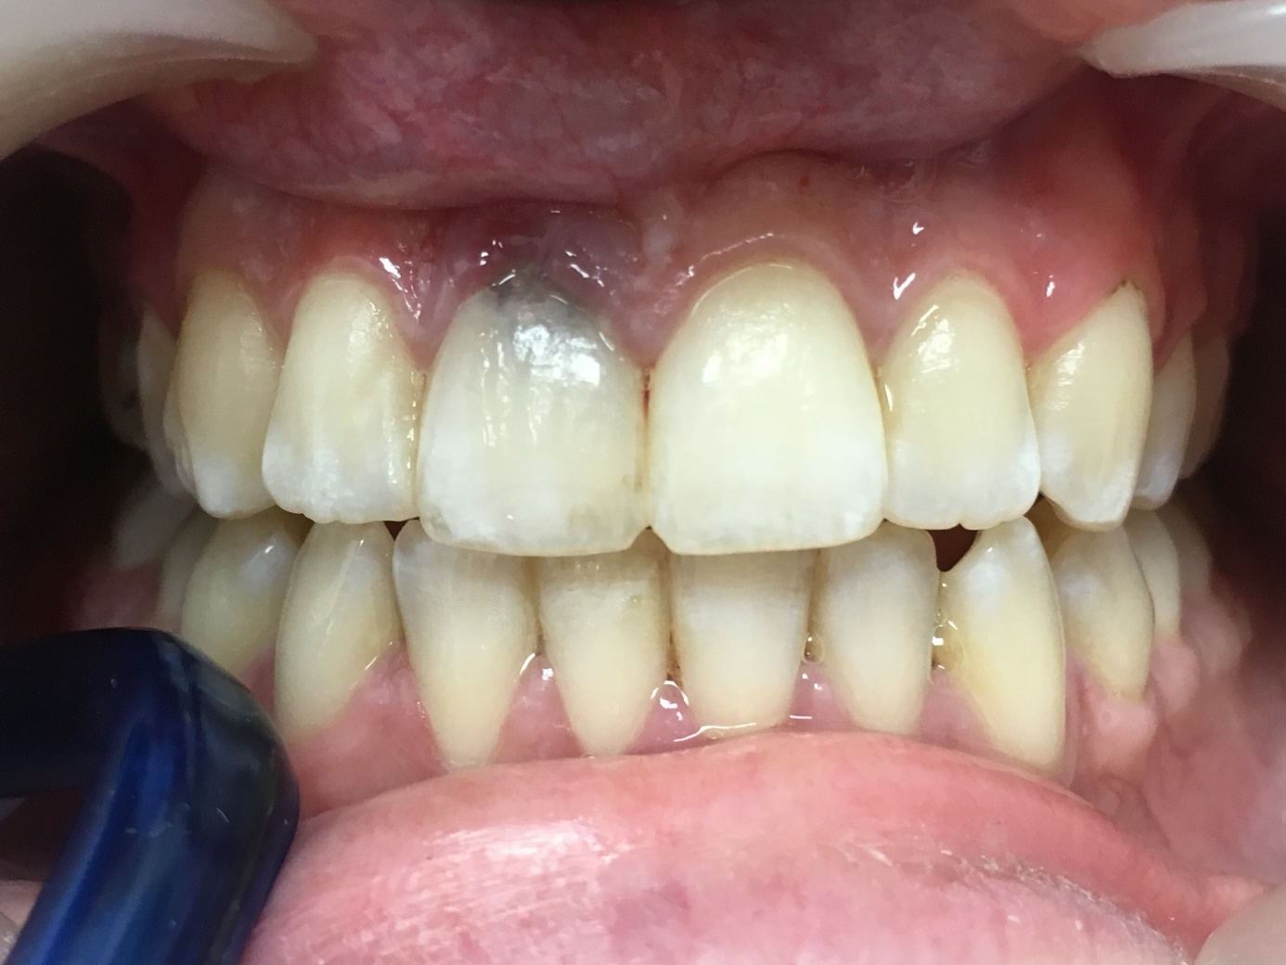

Figure 1. Preoperative intraoral photograph

