Figure 1
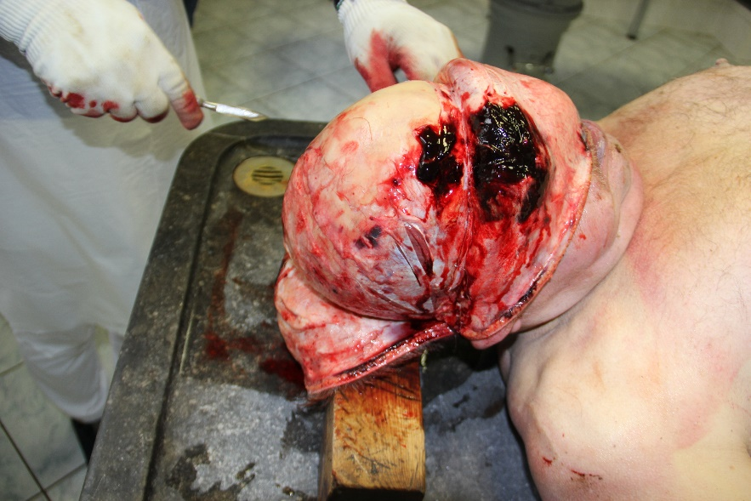
Haemorrhage of the inner side of the scalp
Figure 2
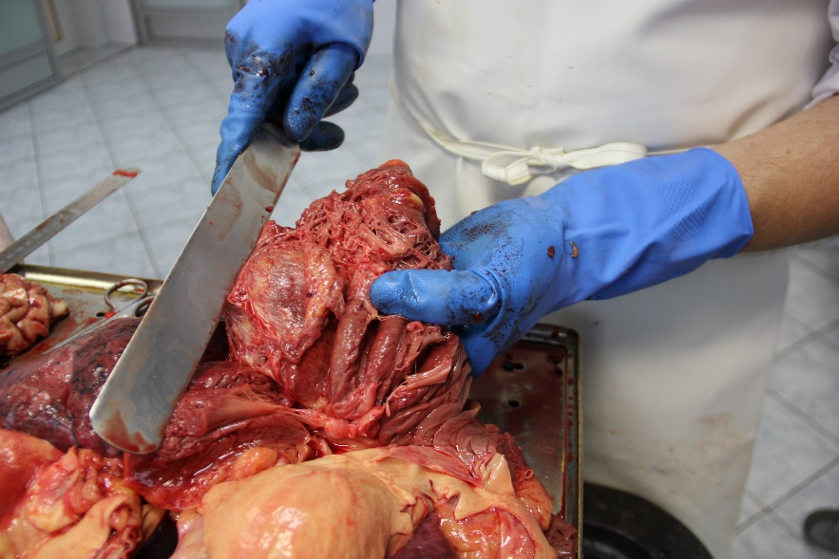
Massive myocardial hypertrophy and extensive postinfarction scarring in the left ventricular wall
Figure 3
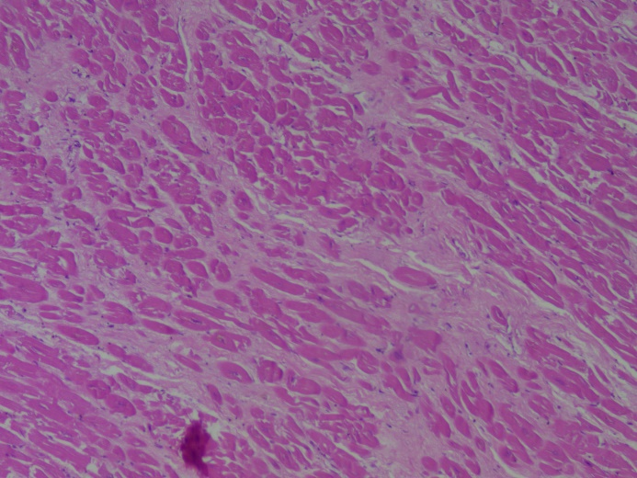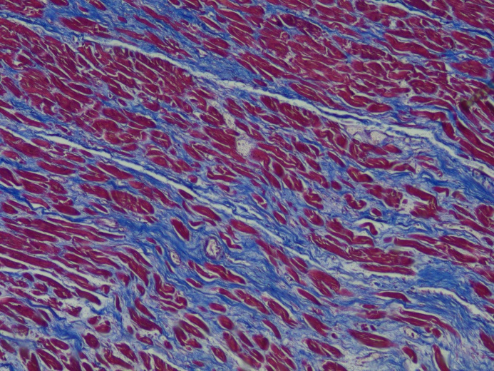
Myocardial sections in hematoxylin and eosin staining (left) and Masson's trichrome (right)

