Ciężkie urazy czaszkowo-mózgowe po wypadkach na hulajnogach elektrycznych w miesiącach zimowych

Severe craniocerebral injury after e-scooter accidents during the winter months

KOWALCZEWSKA Justyna¹, RZEPCZYK Szymon², KOŚCIŃSKI Jeremi³, ŻABA Czesław⁴

¹Department of Neurosurgery and Neurotraumatology, Poznan University of Medical Sciences, Przybyszewskiego 49, 60-355 Poznań, Poland, https://orcid.org/0000-0001-9382-9798
²Department of Forensic Medicine, Poznan University of Medical Sciences, Rokietnicka 10, 60-806 Poznań, Poland, https://orcid.org/0000-0001-6330-1511
³Department of Neurosurgery and Neurotraumatology, Poznan University of Medical Sciences, Przybyszewskiego 49, 60-355 Poznań, https://orcid.org/0000-0001-5673-7456
⁴Department of Forensic Medicine, Poznan University of Medical Sciences, Rokietnicka 10, 60-806 Poznań, Poland
Correspondence author: Szymon Rzepczyk Department of Forensic Medicine, Poznan University of Medical Sciences, Rokietnicka 10, 60-806 Poznań, Poland szymon.rzepczyk@interia.eu

Abstract
As the popularity of e-scooters increases, so does the number of accidents that involve them. The head is one of the areas of the body that is particularly vulnerable to injury as a result of an e-scooter accident. Although the most common types of injuries are abrasions and cuts to the skin, it is the less common severe brain injuries that are the most problematic medically. Most e-scooter accidents occur in the warm months. In winter, when there are unfavorable conditions for using this means of transport, accidents involving them are rare. Described in the text are two severe cases of skull and brain injuries, resulting from accidents while driving an e-scooter, in which neurosurgical intervention was necessary. In both cases, the drivers were under the influence of alcohol and did not use elements of protective gear, such as helmets; which had a measurable influence on the profile and the extent of injuries.
Streszczenie
Wraz ze wzrostem popularności hulajnóg elektrycznych wzrasta liczba wypadków z ich udziałem. Głowa należy do obszarów ciała szczególnie narażonych na urazy w wyniku wypadku na e-hulajnodze. Chociaż najczęstszymi urazami są otarcia i skaleczenia skóry, to występujące rzadziej ciężkie urazy mózgu stanowią najtrudniejszy problem medyczny. Większość wypadków związanych hulajnogami elektrycznymi ma miejsce w ciepłych miesiącach. Zimą, gdy panują niekorzystne warunki do korzystania z tego środka transportu, wypadki z jego udziałem należą do rzadkich. Opisane zostały dwa ciężkie przypadki urazów czaszki i mózgu powstałe na skutek wypadku na hulajnodze elektrycznej, w których niezbędna była interwencja neurochirurgiczna. W obu przypadkach osoby kierujące były pod wpływem alkoholu oraz nie korzystały z elementów odzieży ochronnej takiej jak np. kaski co miało wymierny wpływ na profil i rozległość obrażeń.
Keywords: Electric scooters, Road Accidents, Head injury, ICH

Introduction
In recent years, significant changes in urban micromobility have become noticeable. Electric scooters are becoming more and more popular [1]. Among the most frequently mentioned factors of increased interest in this means of transport are protecting the environment, low price, convenience of moving around the city and saving time [2]. Companies respond to this trend by creating software that allows for quick and convenient short-term rental of scooters via a smartphone. In addition, e-scooters are becoming an alternative to a car when traveling around the city, or commuting to work [3]. In Poland, platforms for renting these vehicles were launched in 2018, originally only in large cities, but now such services are available also in smaller towns [4]. However, the increase in the number of users directly transfers into a significant upsurge in injuries sustained in accidents involving the vehicles [1,5]. Besides the limbs, the area of the body that is the most commonly injured is the head [6,7]. The most prevalent head injuries are: traumatic brain injuries (TBI), soft tissue damage, skull and teeth fractures, as well as intracerebral hemorrhages (ICH) [8,9]. Particularly noteworthy, due to the gravity of consequences are the rare incidents of severe skull and brain injuries sustained in scooter accidents. Two cases of severe cranial and brain injuries selected from patients of the Department of Neurosurgery and Neurotraumatology of the Heliodor Święcicki Clinical Hospital in Poznań from years 2018-2022 are presented.
Case Reports
Case 1
A 33-year-old patient was urgently admitted to the Clinical Department of Neurosurgery in January, after an e-scooter accident, under the influence of alcohol. Physical examination revealed massive facial soft tissue edema and spectacle hematomas. In the initial inquiry of the bone injuries, pathological mobility of the jaw and malocclusion – difficult abduction of the mandible were palpable. A non-contrast CT was performed (Figure 1), which revealed a heterogeneous, hyperdense epidural hematoma (32x60x60 mm) with isolated air bubbles in the left frontal region. By exerting a mass effect, the hematoma displaced the ventricular system by 3 mm to the right. Numerous fractures in the braincase and facial skeleton were detected (Figure 2): comminuted bilateral fracture of the frontal squama, fractures of the orbital walls, bilateral linear fractures of the greater wing of the sphenoid wall - on the right side the fracture gap also extended to the temporal bone, fractures of the walls of the maxillary sinuses, linear fracture of the body of maxilla, comminuted fracture of the nasal bone. Post-traumatic bilateral rupture of the frontozygomatic suture was also observed. The maxillary, sphenoid, ethmoid and partly frontal sinuses, as well as the nasal cavity were filled with bloody content and air bubbles. The injury also resulted in massive hematomas in the subcutaneous tissue in the area of the forehead and eyelids, as well as cutaneous emphysema of both cheeks. The subarachnoid space adjacent to the hematoma was narrowed. The patient was qualified for urgent surgical treatment. On the day of admission, an epidural hematoma was evacuated by left frontal craniotomy. In the control CT of the head, 24 hours after the craniotomy, no signs of an epidural hematoma could be found. Areas of hemorrhagic contusion appeared in the antero-basal parts of the frontal lobes. After two days, reposition and osteosynthesis Le Fort III of craniofacial fractures, as well as nasal reposition were performed. One week later, in a control CT scan of the facial skeleton, tile-like overlapping of bone fragments of the lateral wall of the nose was found and another reposition was performed. After 14 days of hospitalization, once the surgical wounds had healed and the sutures had been removed, the patient was released from the hospital in a generally good condition.

Case 2
In March, 19-year-old patient was hastily admitted to the Clinical Department of Anesthesiology and Intensive Care in Poznań, with a head trauma sustained hitting the wall, while driving an e-scooter. At the time of admission, the patient was in a serious condition, GCS 6/7. A non-contrast CT scan of the head (Figure 3) revealed a cerebral hematoma (6x115x94mm). There were gas bubbles within it. In the cortex of both temporal lobes, ecchymomas were found. Above the hematoma, there were fractures of the parietal bone and temporal squama extending to the base of the skull through the mandibular fossa, the front side of the mastoid, the clivus of the sphenoid bone and the walls of the walls of the sphenoidal sinus. The ventricular system was moved 3 mm to the left, the right lateral ventricle was narrower. The subarachnoid space above the right cerebral hemisphere was narrowed, bloody content had appeared in the sphenoidal sinus and the nasopharynx, a small amount of it was also visible in the right mastoid and the middle ear. Anti-swelling treatment was initiated. The follow-up CT examination revealed larger areas of contusion than the previous one. In addition, there was blood in the right side of tentorium cerebelli. All of the described changes caused a greater mass effect - shifting the ventricular system to the left side by about 5-6 mm. Most of the subarachnoid space below the tentorium was clamped. Due to the features of the deteriorating clinical condition, increasing intracranial compression and symptoms of herniation, the patient had to undergo an urgent of the fronto-parietal-temporal decompression craniectomy and evacuation of the subdural hematoma. The control CT examination, performed 48 hours after the neurosurgical intervention, showed an improvement in terms of the intracranial compartment and about 8 mm thick residual cerebral hematoma in the frontal plane with fresh blood and air bubbles adjacent to the lower parts of the right temporal lobe. Compared to the previous CT, the areas of hemorrhagic contusion in both temporal lobes got larger. Blood was found along the cerebral falx and the tentorium cerebelli. A follow-up CT showed a collection of fluid above the brain at the level of the craniectomy, first 10-11 mm thick, then after 24 h it increased to 13 mm. Additionally, it showcased greater swelling in the areas of the temporal lobes contusion. Due to the patient's fever and high CRP values up to 211 mg/l], it was decided to remove the bone flap sewn into the subcutaneous tissues. Another CT exposed growth in size of the supratentorial hypodense cerebral fluid collection on the right side to 22 mm. A L4/L5 lumbar puncture was performed, releasing 30 ml of yellow, clear cerebrospinal fluid. In the follow-up CT, the fluid collection was observed to have grown to 30 mm. Therefore, a lumbar drainage was placed into the subarachnoid space at the level of L4/L5. A decision was made to perform an early correction of the bone defect with the use of a dedicated implant. Punctures and decompression of the pseudomeningocele were suggested until the procedure is completed. On the 27th day after the decompression craniectomy, a plastic surgery of the bone defect of the right fronto-temporal skull was performed with PMMA cement containing gentamicin using a cranioform. On the 36th day of hospitalization, after stabilization of the clinical condition and normalization of laboratory markers of inflammation, the patient was discharged from the hospital in good condition.
Discussion
Head injuries occurring in patients after accidents on electric scooters are a serious threat to life. An analysis of 5705 casualties of e-scooter-related accidents from 34 studies showed that severe cases of brain injuries are rare (frequency of TBI incidents amounts to 2,5%, ICH to 1,9% and brain concussions to 3,2%), however, they are responsible for the most severe consequences and can lead to death [1,10]. The severity of condition is indicated by the GCS score of 2 in about 2% patients after scooter accidents [11]. Head injuries are the main cause of hospitalization in patients, who were casualties of accidents on e-scooters, the diagnosis of which is based on a CT scan that was also carried out in the described cases. During their hospitalization, patients from cases 1 and 2 were treated in the Clinical Department of Anesthesiology and Intensive Care, which is the case for approximately 1-25% patients in similar condition [12]. Approximately 5-30% also require urgent surgery, including the patient from case 1. Similar craniocerebral injuries, including: subdural hematoma and skull base fractures described above in case 2 are presented in the description of a fatal accident of a 33-year-old man on an e-scooter [10], which indicates the severity of the injuries suffered by the patient in case 2 and the possibility of complications of these accidents leading to death. The basic factors reducing the risk of a head injury in an accident are helmets, however research shows that they are used by less than 5% of scooter riders [13]. In the aforementioned cases, the patients were not wearing helmets at the time of the incident, which undoubtedly contributed to the extent of their injuries. Analyzes of accident statistics involving electric scooters indicate that most commonly they occur in the evening hours during summer weekends [3,14]. The accidents presented above took place in the winter months, when such events are much less frequent [12]. This is due to the great loss number (reaching 80%) of people using this means of transport due to weather conditions e.g. snowfall and frost [15]. Little is known about influence of winter condition on e-scooter accident related injury severity, but icing and reduced grip conditions can lead to more dangerous consequences. They were related to returning from social events in the late evening hours, and the victims were mainly young men controlling the vehicles [14,16,17], which is also confirmed by the aforementioned cases (men aged 33 and 19 respectively). In both cases the casualties were under the influence of alcohol. Being intoxicated while riding an electric scooter is a factor that raises the probability of an accident, as well as the severity of its consequences [3,9,18]. Research indicates that patients under the influence of psychoactive substances are more predisposed to head injuries and have a higher risk of requiring hospitalization, even surgical intervention [9,12], which is also demonstrated by the discussed cases. The type of accident also has a significant impact on the profile and severity of injuries. The most severe injuries are caused by a collision with another, larger motor vehicle (e.g. a passenger car, bus, tram) [4]. Severe complications can also be caused by hitting objects in the environment and elements of road infrastructure (e.g. curbs, hydrants, road safety barriers) [19]. In the described case 2 - patient hit the wall with the e-scooter. Statistically, the lowest risk of serious and life-threatening injuries are spontaneous falls resulting, for example, from a temporary loss of balance [20]. In addition to head injuries, users of electric scooters are often exposed to injuries in the upper and lower limbs [17]. These were also noticeable in the aforementioned patients, although they were mild and of little clinical significance, not requiring additional treatment.

Conclusions
The described cases indicate the possible serious consequences of using an electric scooter. It is essential to introduce systemic and legal solutions aimed at reducing the number of accidents involving electric scooters and mitigating their effects. It seems particularly important to introduce the obligation to use a helmet, which plays a key role in protecting against head injuries. In addition, campaigns should be carried out to raise public awareness of the proper, safe use of electric scooters and the potential risk of an accident. This also applies to the use of a vehicle under the influence of psychoactive substances, the principle of zero alcohol or zero per mile (or even zero pro-mile or zero per-mile) [9] recommended in the literature is fully supported by the authors. In addition to legal and educational activities, it is also important to adapt the urban environment to electric scooters. This can be implemented by designing paths, on which scooters could move and eliminating elements dangerous for drivers, such as high curbs or protruding fragments of barriers. Educating and making e-scooters aware of the impact of weather conditions on safe riding is also important. The influence of season and weather conditions on the typical injury profile has not been well described in the literature, however it should become further research.

All authors declare that they have no conflicts of interest.
We confirm that this work is original and has not been published elsewhere, nor is it currently under consideration for publication elsewhere.
All authors approved the manuscript and its submission to the journal.

1. Singh P, Jami M, Geller J, Granger C, Geaney L, Aiyer A. The impact of e-scooter injuries: a systematic review of 34 studies. Bone Jt Open. 2022 Sep 1;3[9]:674–83.
2. Bretones A, Marquet O. Sociopsychological factors associated with the adoption and usage of electric micromobility. A literature review. Transp Policy. 2022 Oct;127:230–49.
3. Uluk D, Lindner T, Dahne M, Bickelmayer JW, Beyer K, Slagman A, et al. E-scooter incidents in Berlin: an evaluation of risk factors and injury patterns. Emerg Med J. 2022 Apr;39[4]:295–300.
4. Kowalczewska J, Rzepczyk S, Żaba C. E-scooters and the City – head to toe injuries. J Med Sci [Internet]. 2022 Jun 30 [cited 2022 Aug 5];91[2]. Available from: https://jms.ump.edu.pl/index.php/JMS/article/view/672
5. Traynor MD, Lipsitz S, Schroeder TJ, Zielinski MD, Rivera M, Hernandez MC, et al. Association of scooter-related injury and hospitalization with electronic scooter sharing systems in the United States. Am J Surg. 2022 Apr;223[4]:780–6.
6. Toofany M, Mohsenian S, Shum LK, Chan H, Brubacher JR. Injury patterns and circumstances associated with electric scooter collisions: a scoping review. Inj Prev. 2021 Oct;27[5]:490–9.
7. Aizpuru M, Farley KX, Rojas JC, Crawford RS, Moore TJ, Wagner ER. Motorized scooter injuries in the era of scooter-shares: A review of the national electronic surveillance system. Am J Emerg Med. 2019 Jun;37[6]:1133–8.
8. Rashed S, Vassiliou A, Barber J. Neurosurgical trauma from E-Scooter usage: a review of early case series in London and a review of the literature. Br J Neurosurg. 2022 Jan 13;1–12.
9. Hoffeld K, Mair O, Wurm M, Zehnder P, Pförringer D, Biberthaler P, et al. Is the Use of Segways or E-Scooters in Urban Areas a Potential Health Risk? A Comparison of Trauma Consequences. Medicina [Mex]. 2022 Aug 2;58[8]:1033.
10. Aulino G, Polacco M, Fattoruso V, Cittadini F. A cranio-encephalic trauma due to electric-scooter accident: could the wearing of a helmet reduce this risk? Forensic Sci Med Pathol. 2022 Sep;18[3]:264–8.
11. Suominen EN, Sajanti AJ, Silver EA, Koivunen V, Bondfolk AS, Koskimäki J, et al. Alcohol intoxication and lack of helmet use are common in electric scooter-related traumatic brain injuries: a consecutive patient series from a tertiary university hospital. Acta Neurochir [Wien]. 2022 Mar;164[3]:643–53.
12. Kim WC, Campbell AR. Common Injury Patterns from Standing Motorized Scooter Crashes. Curr Surg Rep. 2021 Apr;9[4]:8.
13. Thull-Freedman J, Caird JK. Injuries associated with e-scooter use in the City of Calgary: Canada joins an international conversation. Can J Emerg Med. 2022 Nov;24[7]:675–6.
14. Smit RB, Graham DO, Erasmus J. E-scooter injuries referred to the oral and maxillofacial surgical service at Christchurch Hospital: a retrospective observational study and cost analysis of 17-months of data. Br J Oral Maxillofac Surg. 2021 May;59[4]:439–44.
15. Mathew JK, Liu M, Bullock DM. Impact of Weather on Shared Electric Scooter Utilization. In: 2019 IEEE Intelligent Transportation Systems Conference [ITSC] [Internet]. Auckland, New Zealand: IEEE; 2019 [cited 2022 Dec 5]. p. 4512–6. Available from: https://ieeexplore.ieee.org/document/8917121/
16. Yang H, Ma Q, Wang Z, Cai Q, Xie K, Yang D. Safety of micro-mobility: Analysis of E-Scooter crashes by mining news reports. Accid Anal Prev. 2020 Aug;143:105608.
17. Dhillon NK, Juillard C, Barmparas G, Lin TL, Kim DY, Turay D, et al. Electric Scooter Injury in Southern California Trauma Centers. J Am Coll Surg. 2020 Jul;231[1]:133–8.
18. Kołpa M, Grochowska A, Gniadek A, Jurkiewicz B. Craniocerebral injuries in patients under the influence of alcohol admitted to hospital emergency department in an urgent mode. Med Ogólna Nauki O Zdrowiu. 2016 Apr 4;22[1]:40–5.
19. Rzepczyk S, Majer J, Obst M. ROAD SAFETY BARRIERS AND THE SAFETY OF ROAD USERS – THE ANALYSIS OF THE SITUATION IN POLAND. Logist Transp. 2022;55[2]:85–100.
20. Genc Yavuz B, Zengin Temel T, Satilmis D, Güven R, Çolak Ş. Analysis of electric scooter injuries admitted to the emergency service. Ir J Med Sci 1971 -. 2022 Apr;191[2]:915–8.
Figure 1
CT of patient from case 1
Epidural hematoma (32x60x60 mm) with isolated air bubbles in the left frontal region is visible.
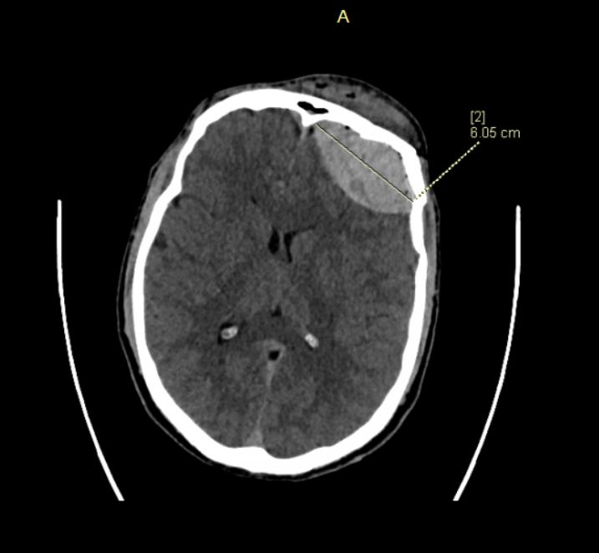

Figure 2
CT 3D reconstruction of patient from case 1
CT shows comminuted bilateral fracture of the frontal squama, fractures of the orbital walls, bilateral linear fractures of the greater wing of the sphenoid wall - on the right side the fracture gap also extended to the temporal bone, fractures of the walls of the maxillary sinuses, linear fracture of the body of maxilla, comminuted fracture of the nasal bone.
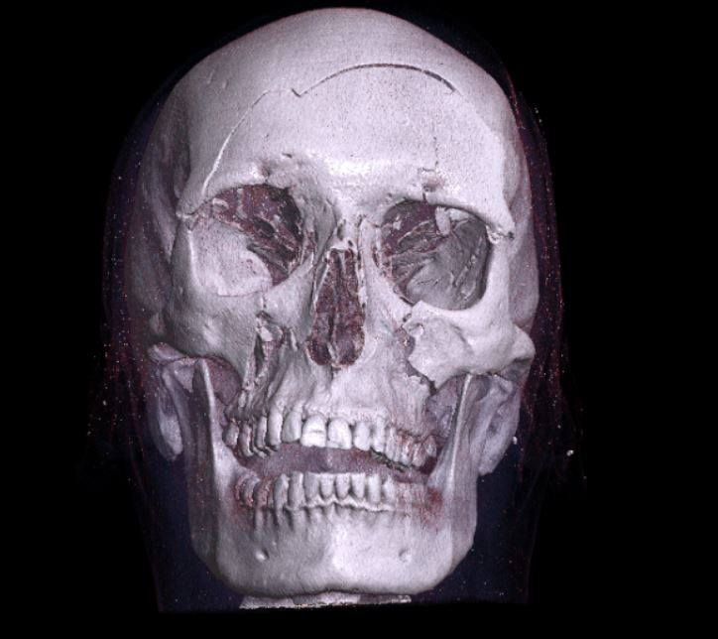
Figure 3
CT of patient from case 2
Cerebral hematoma (6x115x94mm) is visible.
