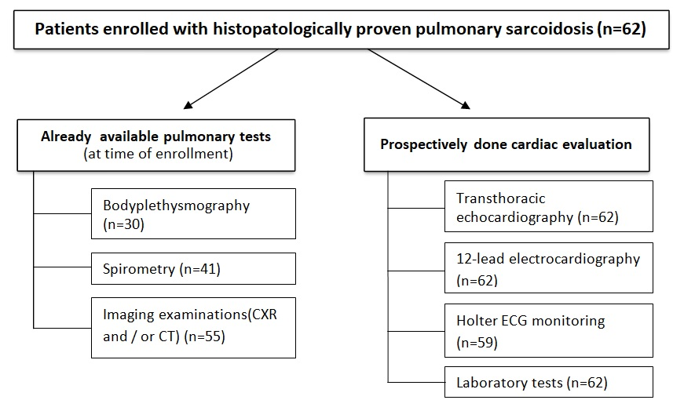
Figure 1. Flowchart of the research.

