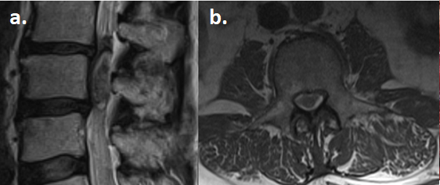
Figure 1. Preoperative imaging. (a) Sagittal and (b) axial T2-weighted MRI demonstrating an intradural extramedullary mass at the level of L3 vertebral body and the resulting compression of the cauda equina.

