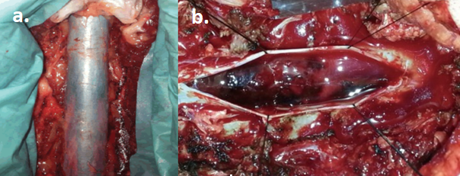
Figure 2. An intraoperative view of the spinal subdural hematoma at the level of L3. (a.) Distended and bluish dura mater can be seen directly over the hematoma. (b.) An intradural view.

