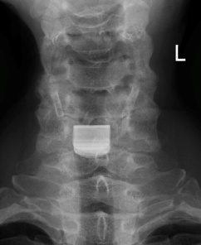
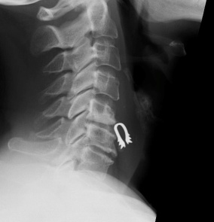

FIGURE 1. Case #5 with anterior dislocation of the C5/C6 intervertebral disc prosthesis. The patient presented with cervical pain of 6 Numeric Rating Scale. This implant was removed and the space was refilled with biodegradable material.

