Introduction
The low asymmetry is a natural feature of the human body, while large deviations from symmetry relate to the pathological factors disrupting the development of structures mainly or only one-sided. Many researches have shown negative correlation between the attractiveness of the face and the degree of its asymmetry (1–3). The significant symmetry disorders, especially those that are in the middle part of the face, are perceived as less attractive (2,3). Due to congenital disorders of tissues development in the middle part of the face, the asymmetry is more visible among patients with cleft lip and palate, both in newborns and those who undergone surgery treatment.
The cleft is a congenital defect, involving partial or complete disruption of continuity of the tissues in typical places associated with embryological development of the face (4). Cleft lip and /or palate accounts for 14-17% of all body malformations and is the most common birth defect in the craniofacial area (5,6). The incidence varies among geographical region and race (7,8). The average incidence of clefts in live-born children in Lodz in 1981-1990 was 2.00 for 1000 live births, in 1991-2000 was 1.89 for 1000, and considering the period of 30 years (1981-2010) was 1.93 for 1000 live births (9–12). Regardless of population or geographical location, the ratio of defect occurrence is 2:1 (men: women). The etiopathogenesis of this defect includes genetic and environmental factors, with the participation of a genetic component at the level of about 20% (13–15). Patient’s treatment is complex and requires interdisciplinary care.
The aim of the study was to assess the extent of facial asymmetry in patients with uni- or bilateral cleft lip and palate.

Material and methods
After local research ethics committee approval (RNN/183/18/KE), sixty-six patients with cleft lip and palate participated in the study: 44 males and 22 females. The age of the patients was 6-36 years old. The unilateral defect was diagnosed in forty of participants (right-sided-13; left-sided-27), while bilateral in twenty-six.
Three anthropometric measurements according to the method of Malinowski and Bożiłow (16) were examined using linear compass and small calipers: the mandibular shaft length (go-gn), the length (na-np) and the width (nl-nm) of the nostrils (Fig. 1).
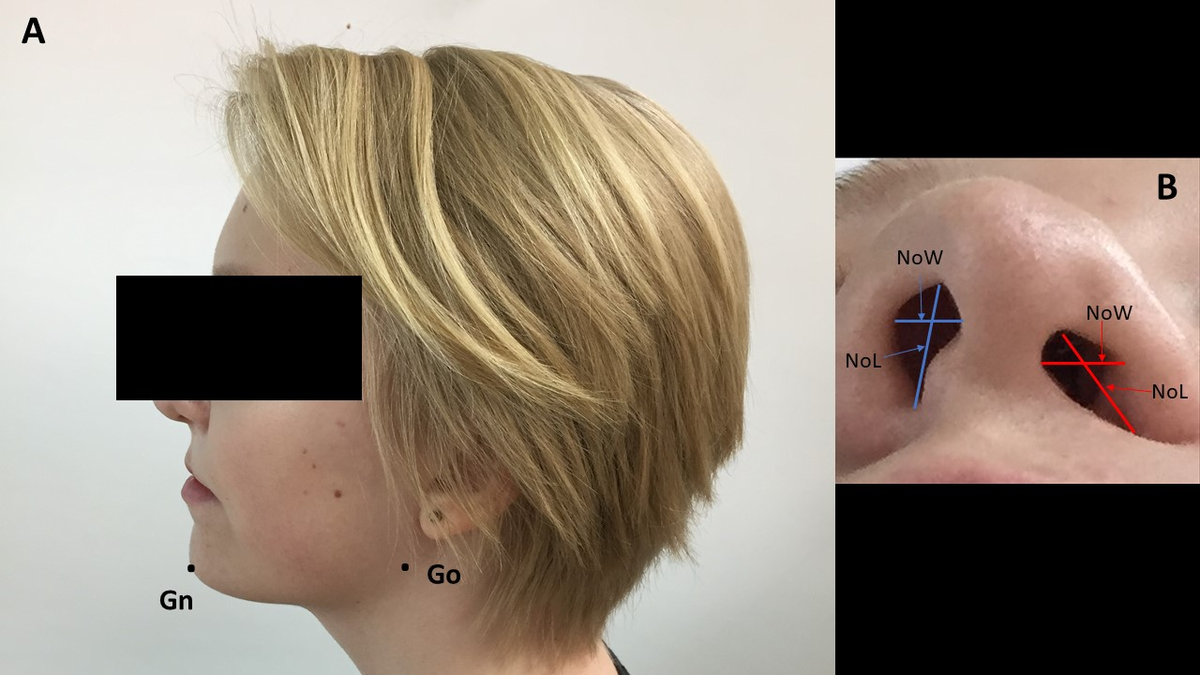
Fig. 1. The anthropometric measurements: A. the mandibular shaft length (go-gn), B. the nostrils: NoW- nostrils width (nl-nm), NoL- nostrils length (na-np), red color- cleft side.

The obtained data were used to calculate the asymmetry index (AI), according to the formula proposed by J. P. Swaddle et al. (17):
R- right
L-left

$$AI= \frac{\left|R-L\right|}{\left(R+L\right)*0.5}$$

However, the formula allows to assess only the size of asymmetry, not its direction, so additionally the differences between right and left (R-L) measurements have been considered. The positive value of this difference indicated direction of asymmetry to the right, while negative to the left side. The value zero meant symmetry. According to the results, the patients were classified into three groups: symmetrical in terms of a given feature (R-L = 0), showing right-handed (R-L > 0) or left-handed asymmetry (R-L < 0). The above classification was used to assess the relationship between the direction of asymmetry and the location of the cleft lip and palate (bilateral, right-sided, left-sided defect).
Then, the obtained data were statistically analyzed. One-way ANOVA was used for evaluation of asymmetry index diversity related to the defect types. The Tukey's HSD post-hoc test was performed when the ANOVA showed statistically significant differences. The connection between the location of the defect and the direction of asymmetry was tested with the chi square test (χ2). For 2x2 contingency tables, the χ² test with the Yates correction was used. In this part of the analysis, due to repeated tests based on the same data, the Bonferroni correction was applied.
A P-value of < 0.05 (or p < 0.0167 in tests with the Bonferroni correction) was considered statistically significant. All calculations and statistical analyses were performed using STATISTICA PL computer software (ver. 12, Statsoft, Poland).

Results

Differentiation in the size of asymmetry of individual facial structures in uni- and bilateral clefts.
The average of the indicators proved that in patients with unilateral cleft, asymmetry mainly affects the nostrils (nl-nm, na-np), but it is not observed within the length of the mandibular shaft (go-gn) (Table 1). All three asymmetry indicators were statistically significant
with the strongest asymmetry concerns the width of the nostril (nl-nm). In patients with bilateral cleft lip and palate, asymmetry also applies only to the length (na-np) and width of the nostrils (nl-nm) (Table 2). The statistical analysis confirmed that the differences between the right and left side are greater for the length and width of the nostrils than for the length of the mandibular shaft (p = 0.0088 and p= 0.0002, respectively). At the same time, no statistically significant differences were found in the extent of asymmetry between the length and width of the nostrils (p = 0.3941).

Determinants of asymmetry in individual facial structures in patients with cleft lip and palate
The sex and age of the patients and the type of cleft do not affect the asymmetry of the length of the mandibular shaft (go-gn) and the length and the width of the nostrils (na-np). However, a negative correlation was observed between the age of patients with cleft and asymmetry of the width of the nostrils, which means that with the increasing age, the smaller asymmetry occurs within this feature. The interaction analysis has shown that this effect (relationship between age and WA nl-nm) is not modified by gender (p = 0.8919) and defect type (p = 0.4933), therefore the reduction in the width asymmetry are not connected with these factors.

The relationship between the direction of asymmetry of individual facial structures and the side of occurrence of cleft lip and palate
In case of the length of the mandibular shaft (go-gn), there is no symmetry found in the examined group. Among persons with bilateral defects, 53.9% of the left-sided measurement dominated over the right-sided, while in 46.1% the right-sided measurement was higher than the left-sided. Almost all people with a defect located on the right side had a longer mandibular shaft on the left (92.3%), while 55.6% of patients with left-sided cleft had a longer mandibular shaft on the right. There was a statistical difference between the cleft location and the direction of the asymmetry in the mandibular length (p = 0.0144). In patients with a defect located on the right side in relation to patients with a left defect, the length of the mandibular shaft on the left side dominates over the right size of this feature (p = 0.0108). At the same time, it was shown that none of the unilateral clefts differs in terms of the direction of the mandibular shaft length asymmetry from bilateral clefts (right-sided vs bilateral p = 0.0412, left-sided vs bilateral p = 0.6821).
In case of the length of nostrils (na-np), the presence of symmetry was noted in 5 people. This feature was symmetrical in 1 individual with bilateral defect (3.9%), 1 patient with right-sided defect (7.8%) and 3 people with left-sided defect (11.1%). The advantage of right-sided measurement over left-sided was found in 46.1% of patients with bilateral defect, the same percentage of people with right-sided defect, and 37.0% of people with left-sided defect. Left-sided asymmetry of the length of the nostrils was shown by 50% of people with bilateral defect, 51.9% of people with left-sided defect and 46.1% of people with right-sided defect. There were no statistically significant relationship between the cleft location and the direction of the asymmetry of the length of the nostrils (na-np) (right-sided vs bilateral p = 0.8710; left-sided vs bilateral p = 0.5487; right-sided vs left-sided p = 0.8429).
The same width of the nostrils occurred in 9 patients, including 7 (26.9%) with bilateral defect and 2 (7.4%) with left-sided defect. The greater width of the nostril on the right was found in 77.8% of patients with left-cleft, 61.5% of patients with right-cleft and 53.9% of patients with bilateral cleft. On the left, the greater width was found in 38.5% patients with right-sided defect, 19.2% of patients with bilateral defect, and in 14.8% with left-sided defect. There were no statistically significant relationship between the location of the cleft defect and the direction of asymmetry of the width of the nostrils (nl-nm) (right-sided vs bilateral p = 0.0889; left-sided vs double-sided p = 0.1182; right-sided vs left-sided p = 0.1770).

Discussion
Many various methods are used to assess the facial asymmetry, including direct measurements of anthropometric points on patients' faces or indirect taken on photographs, video photographs, 3D scans or plaster models of human faces (18). In the present study, direct face measurements with use of linear compass and small calipers were assessed. The advantages of this methodology are the ease of reconstruction of measurements, the possibility of conducting the experiment in outpatient conditions, the lack of invasiveness as well as higher level of acceptance by patients and parents (18,19).
The study evaluated the facial asymmetry of the mandibular shaft and nostrils in patients with uni- and bilateral cleft lip and palate.
Many studies, regardless of the measurement’s method used, did not find the statistically significant differences between asymmetry of the mandible in patients with cleft and compared groups without this defect (20–22). Abuhijleh et al. (20) did not find any asymmetry in patients with unilateral cleft lip and palate, however they observed greater asymmetry in patients from the control group with Angle's first class. Moreover, they noticed that in cleft patients the mandible was shorter, retruded and anteriorly rotated, which may be associated with shorter skull base in cleft patients and the adaptation of the mandible to the underdeveloped maxilla. In our study, the congenital defect did not increase the asymmetry of the mandibular length, however the direction of asymmetry depended on the side of cleft. In unilateral cleft, the mandibular shaft had usually longer length on the healthy side of the face, which is consistent with observations of Abuhijleh et al. (20). Some studies concluded that cleft did not affect growth and development of the mandible (23,24).
The next facial structure subjected to anthropometric evaluation was nose. Our research confirmed the presence of large asymmetry of the nostrils in patients with unilateral and bilateral cleft. It was found that the width of the nostrils is more asymmetrical than length in patients with unilateral defect. Choi et al. (22) analyzed CBCT scans of patients with unilateral cleft lip and palate and found statistically significant asymmetry only in the nasolabial part of the face and in the alveolar process.
The authors pointed out that nasal region related to the large vertical face disturbances. Hoh and Sulaiman (18) demonstrated a coherent connection between preoperative and postoperative asymmetry of lip and nose height. The postoperative asymmetry was worse in more severe clefts than those of the least serious initial deformities. In our study, we observed that with increasing age, the asymmetry of the width of the nostrils in patients with unilateral or bilateral cleft is reduced, which is the result of the surgical treatment. Feijo et al. (25) in a systematic review of morphological changes of nostrils in patients undergoing surgery correction found that there is a significant improvement in nostril asymmetry. The main changes observed after surgery were reduction of the nasolabial angle, decrease of width and increase in the height of the nostrils on the cleft side. Linden et al. (26) evaluated the symmetry of the nose using 3D photogrammetry in patients with unilateral cleft lip and palate and compared them with control group without defect and concluded that cleft patients had significantly greater nose asymmetry. The research results and our own observations suggest that surgery may diminish the symmetry disorders in the nose area, but do not reduce them to the level characteristic of healthy people.

Conclusions:
To sum up, the following conclusions can be drawn:

- There is an asymmetry in the width and length of the nostrils in people with uni- and bilateral cleft. The direction of this asymmetry is not related to the location of the defect (bilateral, right-sided, left-sided).
- Asymmetry of the width of the nostrils decreases with age of patients, regardless of the type of the cleft.
- Cleft lip and palate (uni- and bilateral) does not intensify the asymmetry of the length of the mandibular shaft. The direction of asymmetry depends on the side of the cleft - in unilateral cleft, the mandibular shaft usually has a slightly longer length on the healthy side.

Indicator | Unilateral cleft
 | ͞x | SD | Me | Q1 | Q3 | min | max
WA go-gn | 0,04 | 0,03 | 0,03 | 0,02 | 0,06 | 0,01 | 0,10
WA na-np | 0,14 | 0,10 | 0,12 | 0,08 | 0,17 | 0,00 | 0,44
WA nl-nm | 0,21 | 0,11 | 0,19 | 0,13 | 0,29 | 0,00 | 0,40
Table 1. Statistical characteristics of facial asymmetry indicators in patients with unilateral cleft lip and palate. x- mean, SD- standard deviation, Me- median, Q1- lower quartile, Q3- upper quartile, min-minimum, max-maximum

Indicator | Bilateral cleft
 | ͞x | SD | Me | Q1 | Q3 | min | max
WA go-gn | 0,05 | 0,03 | 0,04 | 0,02 | 0,05 | 0,01 | 0,15
WAna-np | 0,12 | 0,09 | 0,10 | 0,08 | 0,12 | 0,00 | 0,40
WA nl-nm | 0,15 | 0,12 | 0,15 | 0,00 | 0,25 | 0,00 | 0,40
Table 2. Statistical characteristics of facial asymmetry indicators in patients with bilateral cleft lip and palate. x- mean, SD- standard deviation, Me-median, Q1- lower quartile, Q3- upper quartile, min-minimum, max-maximum

